**Output:**

Mutual Friends list:

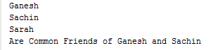

Total Number of Distinct friends:



Some more actions on the list:



